**Is Zumba for Beginners? Yes It Is!**

Is [**Zumba for beginners**](http://www.dalyfstyle.com/PolicyandPrivacy.aspx)? It sure is. It can be a fun, exciting way to lose weight and get in shape. Like most fitness programs, if you are a newbie, you will need to start at the bottom and work your way up. Fortunately, not all Zumba workouts are the same. The workouts vary in intensity and difficulty which enables people of all fitness levels to participate.

[](http://www.dalyfstyle.com/)

Zumba is a dance workout that usually takes place in a class setting. It combines aerobics and dance moves to burn calories and improve your conditioning. It incorporates music and dance steps from hip-hop, salsa, meringue, martial arts, belly dance, and more. The variety of dance steps, movements, and music appeals to most people because the workouts don't get boring.

Zumba sessions usually take place in a gym and the sessions last about an hour. Classes are taught by a certified instructor. If you are a member of a gym that offers classes, you may be able to take the class for free or for a small fee. If you don't have a membership, you may be able to take a class for a fee without signing up for a membership. Each gym has different policies so you need to contact them for class availability.

[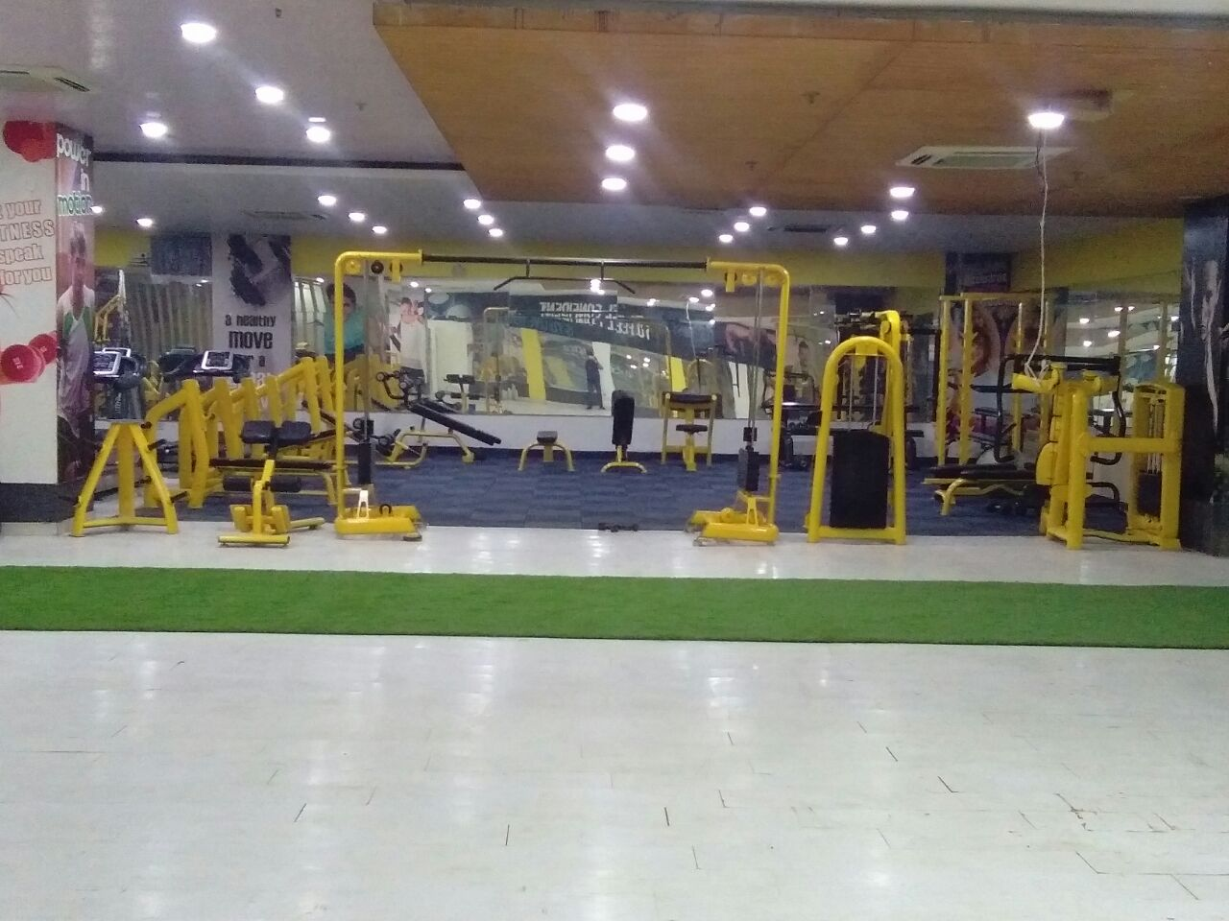](http://www.dalyfstyle.com/)

Taking a class at the gym is a fun experience. Not only is it fun but it also holds you accountable if you take classes with the same group of people. Taking the class with other people will give you motivation to complete the full hour. If you are a beginner, other gym members and the instructor are great resources if you have difficulty mastering the steps.

If the thought of going to the gym makes you feel queasy or your local gym doesn't offer [**Zumba for Beginners at Home**](http://www.dalyfstyle.com/PolicyandPrivacy.aspx), there are DVDs that allow you to do the Zumba dance workout in the comfort of your own home. The benefit of doing the workouts at home is that you can learn the steps at your own pace without feeling out of place among experienced Zumba trainees. Another benefit of a home DVD workout is that you can work out at any time. The gym might not offer a convenient time for you due to work and family commitments.

[](http://www.dalyfstyle.com/)

Zumba is a fun and effective way to get in shape. If you don't like the gym scene or if your gym doesn't offer Zumba for beginners, you can get a home workout video. No matter which options you choose, the key is to be consistent with your workout and you'll see your fitness improve.

If you think you would like to go the home fitness route, check out these Zumba **Dalyfstyle** Reviews. We provides best Video for [**Zumba for Beginners at Home**](http://www.dalyfstyle.com/PolicyandPrivacy.aspx).